**VAN DEN HEUVEL — Mapping**

<4 figures>

**Mapping Notes and Nodes: Building a Multilayered Network for a History of the Cultural Industry**

Van den Heuvel, C., Van Bree, P., Kessels, G. and Álvarez-Francés, L.

In August 2014, for the first time in its history, *Science* included an article of an art historical nature. Art historian Maximilian Schich (2014), together with a team of experts on network theory, modeling, simulation, and visual analytics, mapped cultural migration on a global level by aggregating data of Freebase.com, the General Artist Lexicon, and the Getty Union List of Artists’ Names. Mauro Martino (2014) made an animated visualization in which the dynamics in the birth and death locations of more than 150,000 artists and scientists on a global level can be followed over a period of 2,000 years in a five-minute movie. We agree with some of the critique that the predominantly American–North European nature of the dataset, its focus on artists, and its scope on birth and death dates are too limited to map cultural migration on a global level. It should be complemented with data about the roles and interactions of various actors such as painters, comissioners, cultural agents, scholars, academies, etc., and about the artefacts they produced. However, the article in *Science* describes an interesting experiment in which a combination of qualitative and quantitative methods were tested that are needed for any global history. Moreover, as the title explains, the authors did not claim other than to provide ‘a network framework of cultural history’.

In this paper we discuss the outcomes of another experiment that might be used to complement and enhance this global network framework gradually both with ingests of other cultural data and overlays of manually created networks of micro-histories. In a private-public project known as Mapping Notes and Nodes in Networks (Álvarez Francés and van den Heuvel, 2014), a small interdisciplinary team experimented for nine months for two days per week with the software application Nodegoat to create multilayered networks of actors and documents that are potentially relevant for the history of the creative industry in Amsterdam and Rome in the Early Modern Period.1 The project started with the integration of three complementary, but heterogeneous (meta)datasets: the full text searchable Biographical Reference Works of the Huygens Institute for the History of Netherlands; ECARTICO, a comprehensive database that allows analysing and visualising data concerning painters, art consumers, art collectors, art dealers, and others involved in the cultural industry of Amsterdam and the Low Countries in the Early Modern Period; and finally HADRIANUS, a database of Dutch artists and scholars from the Middle Ages up the 20th century who stayed in Rome, developed by the Royal Netherlands Institute in Rome. Researchers who heard of the initiative offered their own sets. Frits Scholten and Arjan de Koomen provided the data about the migration of Dutch sculptors throughout Europe that their students had assembled in the project Sculptors on the Move. Susanna de Beer, with a small group of students, developed in her Mapping Visions of Rome project a typology of descriptions of Rome in humanist poetry. We embraced this rather arbitrary selection of sources to complement our three initial datasets, because it reflects the main research question of the Mapping Notes and Nodes project: ‘How can we assess which information is relevant when integrating reused completed datasets with those in development?’ Despite initiatives such as the Internet Archive or Library Alexandria 2.0 we claim that full data integration of digitized sources and digital-born data on a global level is impossible. Therefore, strategies are needed that can bring together top-down and bottom-up approaches and enable handling hybrid forms of data integration in continuous flux. For that reason in this project the emphasis was not on quantitative analyses but on a qualitative approach to allow scholars to connect and complement these divergent datasets and to create and visualize networks to see and interact with connections that they might not do otherwise. To this end, it was decided to develop a viewer for Nodegoat that visualises the co-presence of historical actors (nodes) and (meta-)data of sources and documents (notes) in Amsterdam and Rome in partially overlapping, multilayered networks (see Figure 1).

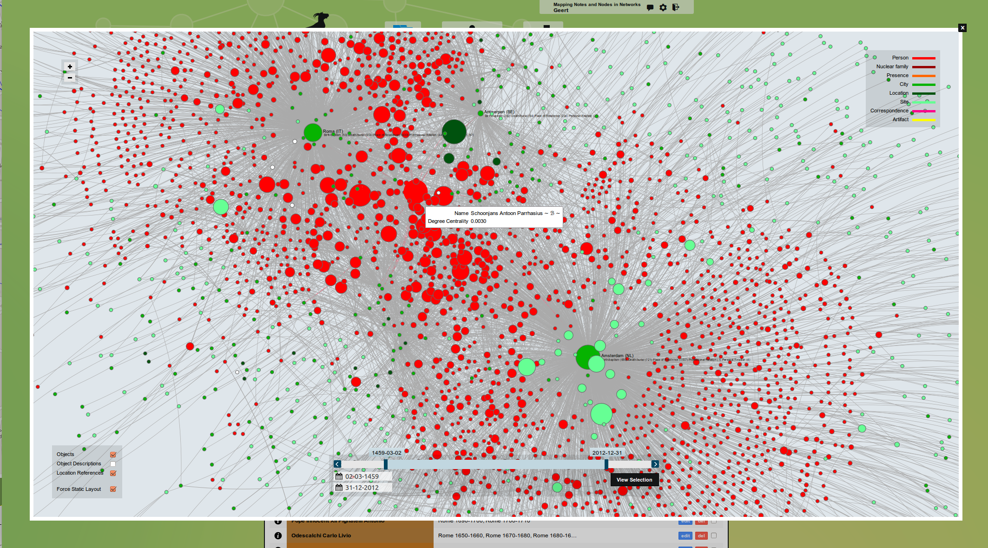

Figure 1. Network of persons with both relations in Rome and in Amsterdam and their interrelations.

The assumption is that the co-presence of artists, artisans, scientists, art agents, ambassadors, patrons, sponsors, and entrepreneurs at a certain location in a given time period allows for recognizing potential networks, while contextual topical information (introduction letters, guest lists, audiences, commissions, contracts, artefacts) enable users to assess whether there were actually contacts between these persons. When new data is added, the overlap of the multilayered networks changes, resulting potentially in new answers and other questions. The building of hybrid networks implies perhaps a less systematic research of the history of the creative industry of Rome and Amsterdam, but at the same time both practical and theoretical arguments support this more explorative approach. First of all, this approach seems to reflect the way (digital) humanists assemble information on the basis of rather pragmatic criteria such as time, money, and availability of data. If complete data integration is impossible, a tool that on the basis of metadata enables assessing the likelihood that one combination might lead to better results than another could at least support prioritizing the digitization program necessary for research. The second, theoretical argument is that the proposed incremental approach with changing perspectives on data in flux stands closer to hermeneutic methods (Capurro, 2010). Such methods appeal to many humanities scholars who try to give sense to data from multiple perspectives in continuous processes of reinterpretation (Akker et al., 2011). For that reason we chose a couple of cases that could demonstrate the multidimensional relationships from data about the cultural industry of Amsterdam and Rome from different perspectives. Since the Ecartico database provides visualizations of the places where artists lived in Amsterdam, we decided to map the geolocations of Dutch artists in Rome as well, using inventories of the parochial archives by Hoogerwerff (Tamminen, 1943).

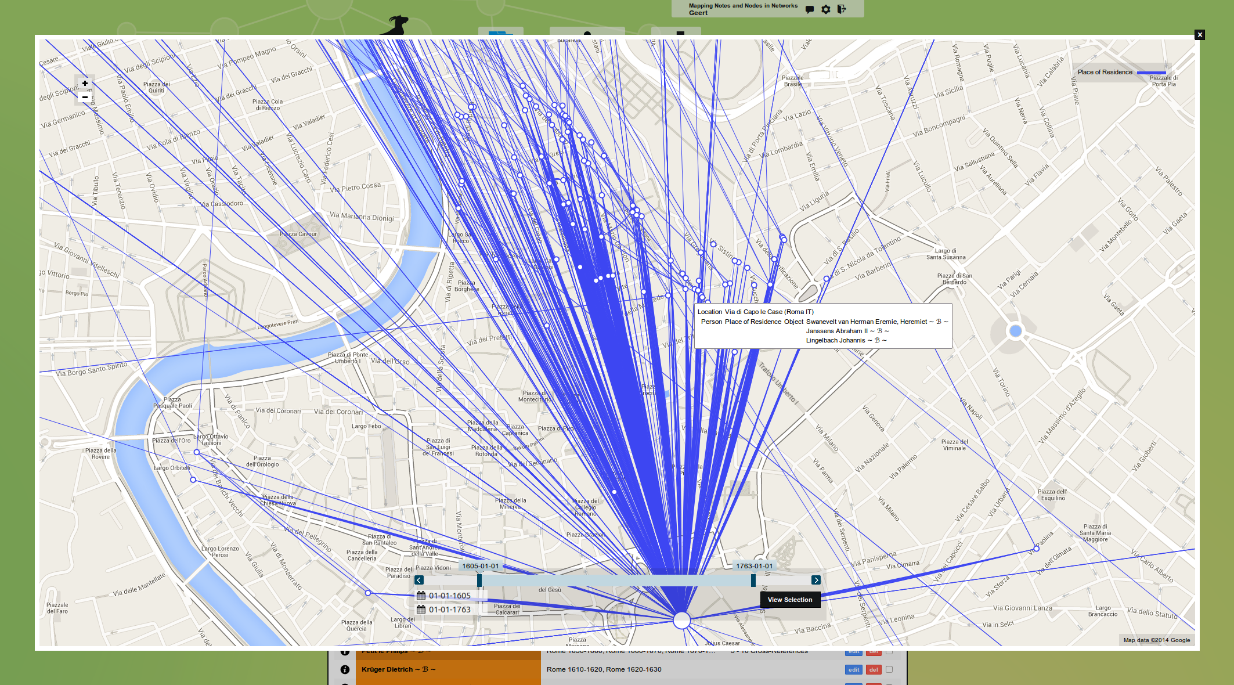

Figure 2. Location of the ‘Bentvueghels group’ with pop-up of artists living in the same house.

This mapping reveals a very high concentration of Dutch artists living three or four together in one house, almost from door to door in just a couple streets (see Figure 2). This tight community of artists, known as the Bentvueghels, worked and partied together in Rome between approximately 1620 and 1720.

However, we did not only look at relations between artists. Other cases show networks of actors in the creative industry from the perspectives, respectively, of a Dutch pharmacist and a Dutch engineer in Rome. Pharmacist Hendrik Raef, alias Corvinus (ca. 1554/1567–1639), probably provided pigments to painters and was a member of the Bentvueghels group. The Dutch civil engineer Cornelis Meijer (1629–1701) created on commission of three successive popes constructions against floods and to make the Tiber navigable. These constructions are hard to link to the creative industry, but that is different for the commissions he gave to several Dutch and Flemish artists in Rome to make engravings after his designs (see Figure 3).

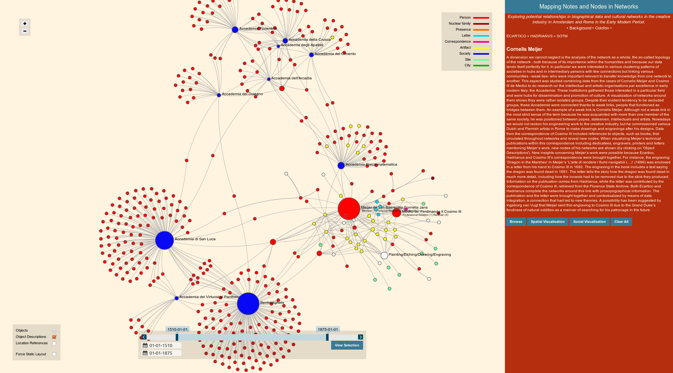

Figure 3. Network of people and academies (nodes) and artefacts (notes) around engineer Cornelis Meijer.

Given the possibility to indicate the nature of relationships as well, we also mapped his competitors. Another case looks into the Dutch contacts of Italian engineers who on behalf of Cosimo III, grand duke of Florence (1629–1701), were involved in espionage of Dutch industries and fortifications. While these cases demonstrate relationships between different actors (the nodes) in overlapping networks, other reveal links from the perspective of the artefacts or contextual documents (notes). For instance, the above-mentioned typology of descriptions of Rome in poems of humanists is linked to categories in ICONCLASS to compare these associations with the classification of visual depictions of the Eternal City and its monuments (see Figure 4).

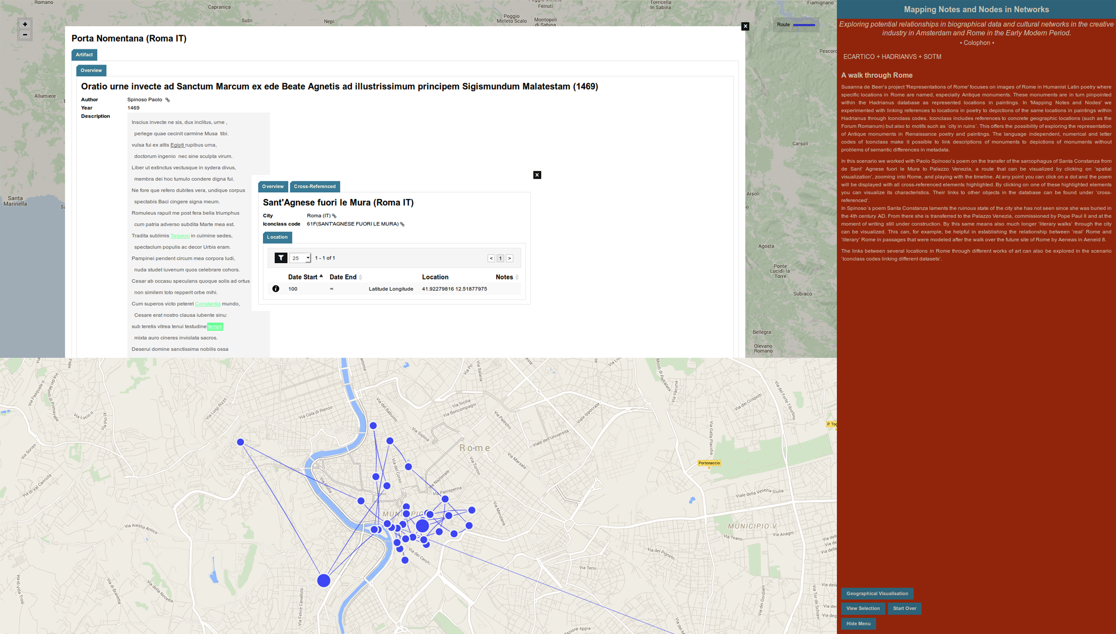

Figure 4. ICONOCLASS numbers connecting depictions and descriptions of monuments in Rome.

The combination of incomplete, heterogeneous digitized, and manually added data will result in much fuzziness and uncertainties in interpretations of the history of the cultural industry of Amsterdam and Rome. In order to assist the user in assessing the quality of data, the producer hereof can annotate them with levels of uncertainty. Although this experiment for a multilayered network of actors and documents was set up around some cases relevant for the history of the creative industry of Amsterdam and Rome, its features of digital hermeneutics to deal with overlaps, multiple perspectives, fuzziness, and uncertainties in data have a much larger potential to enhance existing network frameworks developed for global history.

**Acknowledgements**

The authors are indebted for the data and expertise of Marten-Jan Bok and Harm Nijboer (University of Amsterdam-Ecartico); Marieke van den Doel and Arthur Westeijn (Royal Netherlands Institute in Rome-Hadrianus); Susanna de Beer and Petrie van der Heijden (Leiden University); Hans Brandhorst and Etienne Postumus (Mnemosyne-Iconclass); Arjan de Koomen (UvA) and Frits Scholten (Rijksmuseum; VU University Amsterdam); Sebastiaan Derks and Ronald Sluijter (Huygens Institute for the History of the Netherlands) Alette Fleischer (independent researcher—Corvinus and Bentvueghels); and Erin Downey (Temple University Philadelphia: Patronage Guistiniani and Bentveughels).

**Note**

1. Charles van den Heuvel was main applicant and p.i. of the Mapping Notes and Nodes in Networks project. Leonor Álvarez Francés was embedded researcher in LAB1100, the studio of Pim van Bree and Geert Kessels that developed the described features for this project in Nodegoat. Ingeborg van Vugt and Simone Wegman (Leiden University) worked as interns on this project at the Huygens Institute for the History of the Netherlands.

**References**

**Akker, C. v. d., et al.** (2011). Agora Digital Hermeneutics: Online Understanding of Cultural Heritage. Proceedings of the 3rd International Conference on Web Science (WebSci’11), Koblenz, Germany, 14–17 June 2011, http://www.cs.vu.nl/~guus/papers/Akker11a.pdf.

**Álvarez Francés, L. and Heuvel, C. v. d.** (2014).*Mapping Notes and Nodes in Networks: Exploring Potential Relationships in Biographical Data and Cultural Networks in the Creative Industry in Amsterdam and Rome in the Early Modern Period.* Report: Royal Netherlands Academy of Arts and Sciences (KNAW) Public Private Partnership Project:

https://www.huygens.knaw.nl/mapping-notes-and-nodes-in-networks/?lang=en, and for the viewer, http://mnn.nodegoat.net/viewer.

**Capurro, R.** (2010). Digital Hermeneutics: An outline. http://www.capurro.de/digitalhermeneutics.html.

**Martino, M.** (2014). http://www.nature.com/news/humanity-s-cultural-history-captured-in-5-minute-film-1.15650; http://youtu.be/4gIhRkCcD4U.

**Nodegoat.** (n.d.). http://nodegoat.net/.

**Schich, M., et al.** (2014). A Network Framework of Cultural History. *Science,* **345**, 558–62,

DOI:10.1126/science.1240064.

**Tamminen, M.** (1943). *Nederlandse kunstenaars te Rome 1600–1725. Uittreksels uit de parochiale archieven door G.J. Hoogewerff,* The Hague.